

**Discrete Structure**

**Lab Assignment-III**

**Submitted by:-**

Name: Aadarsha Bhattarai

Roll No.1

1**.Program to Compute an**

#include<iostream>

using namespace std;

int a_pow_n(int a,int n)

{

int b=1;

int i;

for(i=1;i<=n;i++)

{

b=b*a;

}

return b;

}

int main(){

int a,b,x;

cout<<"Enter Base:"<<endl;

cin>>a;

cout<<"Enter Power:"<<endl;

cin>>b;

x=a_pow_n(a,b);

cout<<"The"<<a<<"^"<<b<<"\t="<<x<<endl;

return 0;

}

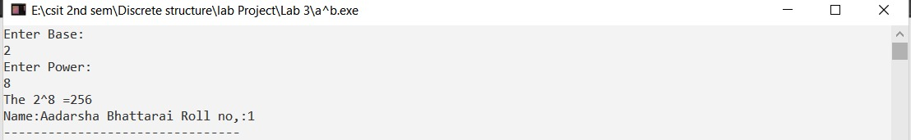

**2.Program to compute bn(mod m)**

#include<iostream>

using namespace std;

int main()

{

int base,power,mod_divisor,i,num2;

int num=1;

cout<<"Enter Base:";

cin>>base;

cout<<"Enter Power:";

cin>>power;

cout<<"Enter Modular divisor:";

cin>>mod_divisor;

for(i=1;i<=power;i++)

{

num=num*base;

}

num2=num%mod_divisor;

cout<<base<<"^"<<power<<"("<<"mod"<<mod_divisor<<")"<<"\t:"<

<num2;

cout<<"\nName:Aadarsha Bhattarai\tRoll no:1";

return 0;

}

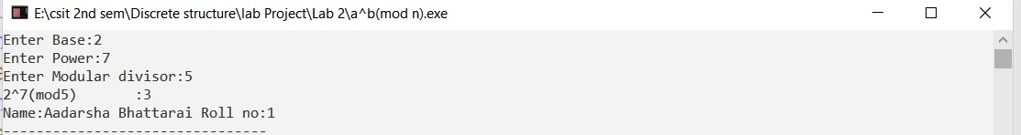

**3.Program for Linear search**

#include<iostream>

using namespace std;

int linear_search(int array[],int num)

{

int i=0;

for(i=0;i<

num;i++)

{

if(array[i]==num)

{

cout<<"\nThe Number "<<num<<" at Index:"<<i;

break;

}

}

if(i==num)

{

cout<<"\nSorry!The number is not in Array"<<endl;

}

}

int main()

{

int array[10]={2,45,69,56,37,84,99,26,16,72};

int num;

cout<<"Enter Number to search:";

cin>>num;

linear_search(array,num);

cout<<"Name:Aadarsha Bhattarai\tRoll no,:1";

}

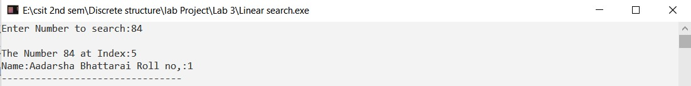

**4.Program to find factorial of a number**

#include<iostream>

using namespace std;

int fact(int n)

{

if (n==1)

{

return 1;

}

else

{

return n*fact(n-1);

}

}

int main()

{

int num;

cout<<"Enter number to compute Factorial:"<<endl;

cin>>num;

cout<<"The factorial of "<<num<<"="<<fact(num);

return 0;

}

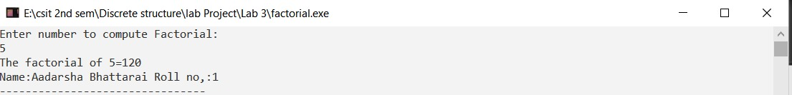

**4.Program to show Fibonacci Series upto nth term**

#include<iostream>

using namespace std;

int fib(int n)

{

if (n==1)

return 0;

else if(n==2)

return 1;

else

return fib(n-1)+fib(n-2);

}

int main()

{

int num,i;

cout<<"Enter Number of terms for Fibonnaci Sequence:\t"<<endl;

cin>>num;

cout<<"The Sequence is\n"<<endl;

for(i=1;i<=num;i++)

{

cout<<fib(i)<<"\t";

}

return 0;

